**Presentation Outline:**

**Title of Your Presentation:** Include the names of students in the group.

**Quick Introduction:** Briefly discuss topic or problem. Why you chose it. What it means to you. Your solution.

**Problem Topic Slide:**  Discuss problem or topic in more detail than on previous slide, add visual that illustrates problem.

**Who Are Stakeholders Involved in Your Issue & How are They Impacted?** Discuss people impacted by issue you chose. How are they impacted?

**Steps You Took to Learn More About Issue & What You Learned:** Discuss your research findings that led you do decide on your action. What previous actions have been taken? Were they successful? Difficulties You Encountered While Completing Your Project & How You Overcame Them. What problems arose during the completion of this project? How did you deal with or work around those issues?

**Solution Slide:** Include your solution, objective or action. A visual that illustrates your objective**.** Talk about your objective in more detail than you did in your quick intro

**Your Action & Outcome:** Discuss your action. How it was implemented. Outcome. Was it successful?

**Your Group's Reflection:** What did you learn while completing this project? What have you learned about how the "system" works? What skills, knowledge or understandings could you take with you to college or into your life as an engaged citizen? What might you have done differently if you were to start this project over? Overall, how satisfied are you with the outcome of your project?

**Questions from Committee:** Be prepared to take specific questions from committee members.

**Presentation Checklist**

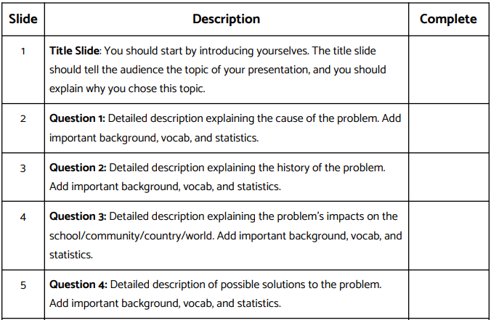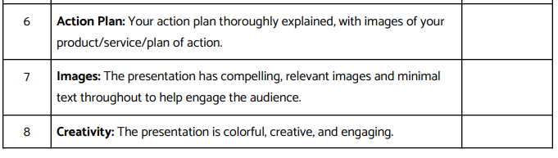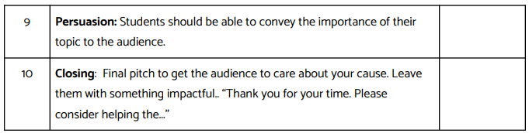

**Presentation Rubric**

